**Course Specialist Test 1 Year 12**

Student name: ________________ Teacher name: ________________

**Task type: Response**

**Reading time for this test : 5 mins**

**Working time allowed for this task: 40 mins**

**Number of questions: 7**

**Materials required:** No cals allowed!!

Standard items: Pens (blue/black preferred), pencils (including coloured), sharpener, correction fluid/tape, eraser, ruler, highlighters

Special items: Drawing instruments, templates, notes on one unfolded sheet of   
A4 paper, and up to three calculators approved for use in the WACE examinations

**Marks available: 42 marks**

**Task weighting: 13%**

**Formula sheet provided: no**

**Note: All part questions worth more than 2 marks require working to obtain full marks.**

**Useful formulae**

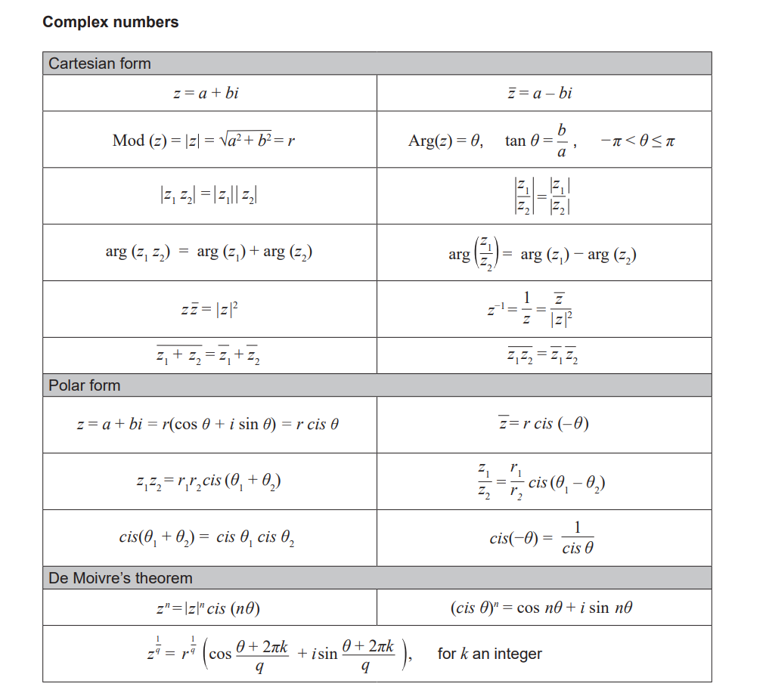

**No cals allowed!!**

Q1 (2, 2, 2 & 2 = 8 marks)

If  and  determine the following exactly.

1. 

|  |
| --- |
| **Solution** |
|  |
| **Specific behaviours** |
| 🗸 real part  🗸 imaginary part |

1. 

|  |
| --- |
| **Solution** |
|  |
| **Specific behaviours** |
| 🗸 real part  🗸 imaginary part |

1. 

|  |
| --- |
| **Solution** |
|  |
| **Specific behaviours** |
| 🗸uses conjugate  🗸 states result |

1. 

|  |
| --- |
| **Solution** |
|  |
| **Specific behaviours** |
| 🗸uses conjugate  🗸 states result |

Q2 (4 marks)

Determine all possible real number pairs  such that .

|  |
| --- |
| **Solution** |
|  |
| **Specific behaviours** |
| 🗸 equates reals and imaginaries  🗸 sets up an equation with only one variable  🗸 solves for two a values  🗸 solves for two b values |

Q3 (2, 3 & 3 = 8 marks)

Consider the function .

1. Determine .

|  |
| --- |
| **Solution** |
|  |
| **Specific behaviours** |
| 🗸 shows all 4 terms  🗸 final answer of zero  (Zero marks if all 4 terms not shown) |

1. Hence solve 

|  |
| --- |
| **Solution** |
|  |
| **Specific behaviours** |
| 🗸 uses conjugate  🗸 shows full factorisation of f  🗸 states all 3 roots |

1. Consider  where  are real constants and . Determine the values of .

|  |
| --- |
| **Solution** |
|  |
| **Specific behaviours** |
| 🗸 uses conjugates  🗸 shows factorisation of each quadratic  🗸 states all 4 constant values |

Q4 (3 marks)

Use the diagram below to determine the complex number  in polar form with a principal argument.

(diagram not drawn to scale)

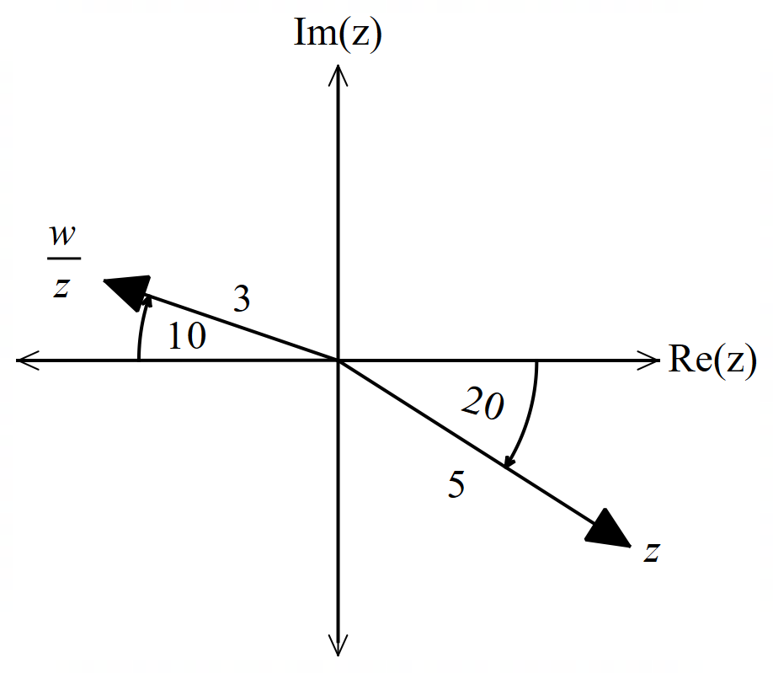

|  |
| --- |
| **Solution** |
|  |
| **Specific behaviours** |
| 🗸 determines r of w  🗸 determines argument of w  🗸 states w in polar form |



Q5 (2 & 3 = 5 marks)

Sketch the following regions on the axes below.

1. 

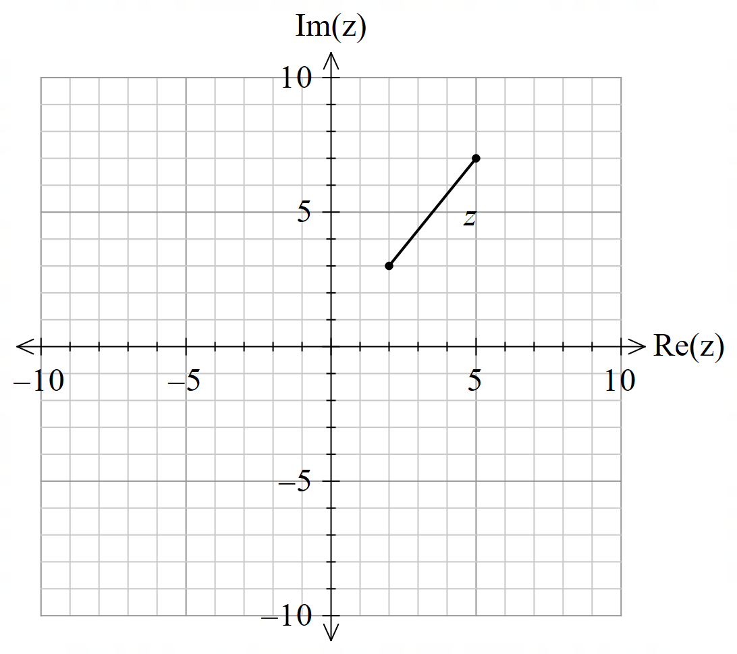

|  |
| --- |
| **Solution** |
|  |
| **Specific behaviours** |
| 🗸 shows a line segment of length 5 units  🗸 plots correct endpoints of closed line segment (includes endpoints) |

1. 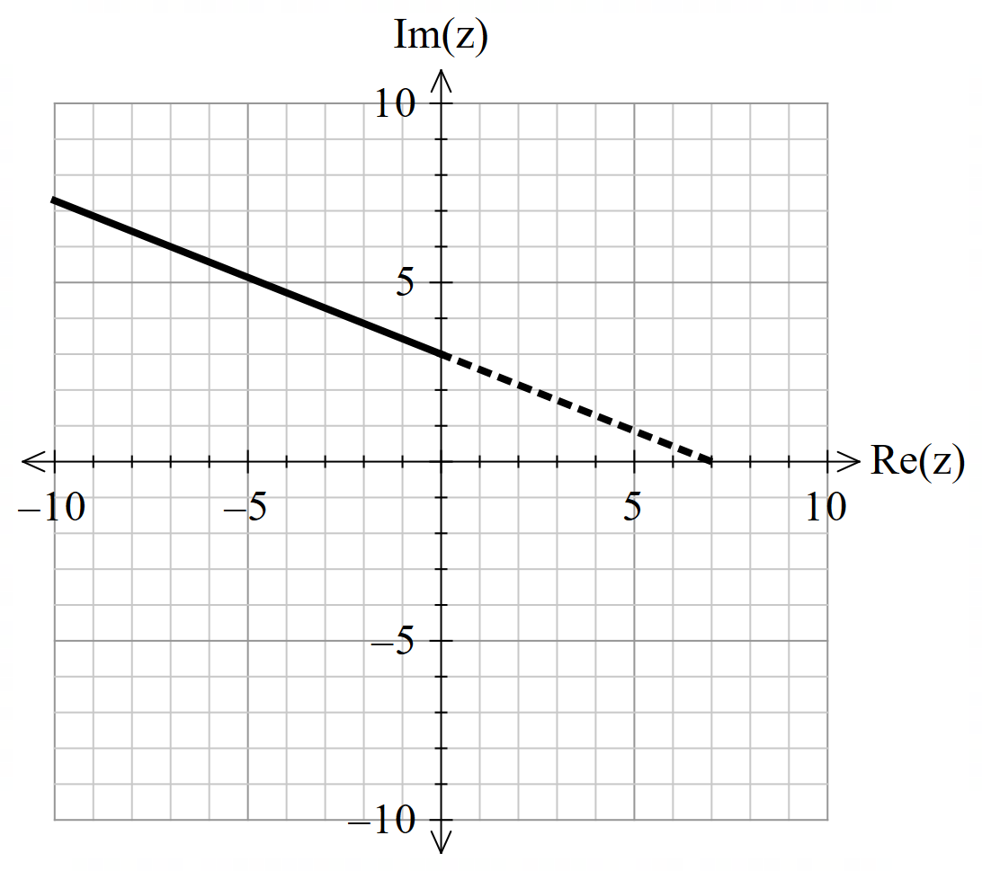

|  |
| --- |
| **Solution** |
|  |
| **Specific behaviours** |
| 🗸 shows a line segment open (i.e arrow)  🗸 plots y coordinate  🗸 plots a dotted line segment to 7 on real axis |

Q6 (5, 2 & 2 = 9 marks)

1. Solve  in polar form with principal arguments.

|  |
| --- |
| **Solution** |
|  |
| **Specific behaviours** |
| 🗸converts RHS to polar form  🗸 shows use of De Moivres  🗸 states 6 roots with same modulus  🗸 all roots equally spaced  🗸all arguments in Principal form |

1. Plot these points on the axes below.

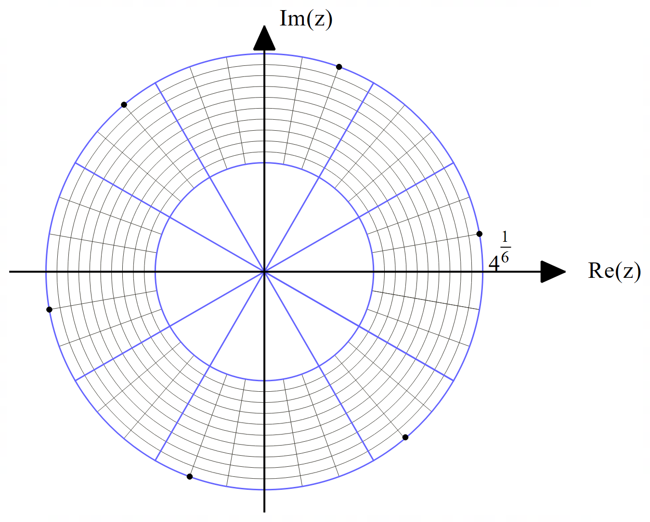

|  |
| --- |
| **Solution** |
|  |
| **Specific behaviours** |
| 🗸 scale shown with 6 roots equally spaced  🗸 correct positions for all roots |

1. Determine the area of the polygon formed by joining the points in (b) above.

|  |
| --- |
| **Solution** |
|  |
| **Specific behaviours** |
| 🗸 uses 6 equilateral triangles  🗸 states exact value in surd form |

Q7 (5 marks)

The locus of  where  are real constants is plotted below and can also be defined as . Determine the values of  showing full reasoning.

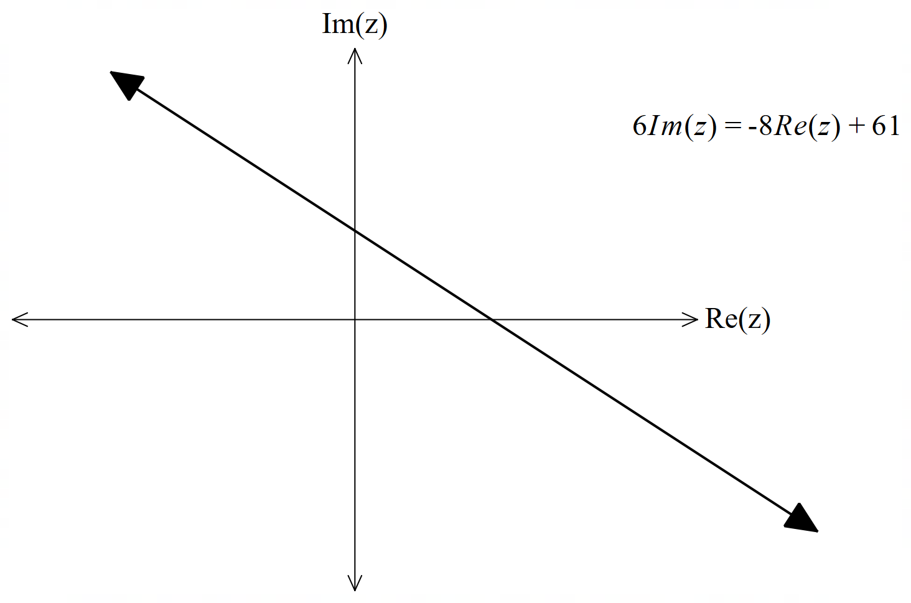

|  |
| --- |
| **Solution** |
| Midpoint  Gradient of dotted line  perpendicular to locus line |
| **Specific behaviours** |
| 🗸 identifies two major points in terms of a&b OR subs z=x+iy into both sides  🗸 uses midpoint and subs into line equation OR squares both sides and eliminates squared terms.  🗸 uses perpendicular gradient and major points OR subs eqn of line  🗸 sets up two simultaneous eqns for a&b  🗸solves for both a & b |

